# Scenario #1

## Scenario Description

* When a player loses double their bet when they lose. When a player doesn’t get a match, their balance goes down by twice the amount they bet.
* For example, if the player bets $5 on Prawn and the dealer rolls 2 Fish and 1 Stag then the player loses $10. The player is only mean to loses their bet of $5.

## Version Control

|  |  |  |  |
| --- | --- | --- | --- |
| Version # | Date | Author | Description |
| 0.1 | 18/10/2019 | James Bell | Initial Draft |
| 1.0 | 18/10/2019 | James Bell | Initial Version |

## Test Scripts

The following scripts will cover this scenario:

* 1.1 Test Script #1
* 1.2 Test Script #2

## Test Components/Requirements

This test scenario covers the following high-level test requirements (see scripts below for specific requirements covered by each test script):

* Component 1
* Component 2
* Functional Requirements Group 1

## Script #1

### Script Description

* Launch program and play interactively with any balance, bet limit and bet and select any dice picture. Once selected if the game is lost your balance is updated and displayed as negative double your bet.

### Testing Requirements

This test script covers the following specific testing requirements:

* Any balance, bet limit and bet amount
* Any dice picture selected (e.g. Fish, prawn, rooster, crab, courd or stag)
* Must loss the roll and have wrong dice picture from the 3 dices.

### Setup

* Must be playing either play interactively.
* Must have a balance, bet limit and bet amount higher than 0.

### Teardown

* List all steps that should be taken after the test case is executed

### Script Steps

| **Step #** | **Test Action** | **Expected Results** | **Pass/ Fail** |
| --- | --- | --- | --- |
| 1 | Launch program | Launches successfully | pass |
| 2 | Select p (play interactively) | Askes for player name | pass |
| 3 | Input player name | Askes for initial balance | pass |
| 4 | Input initial balance | Askes for bet limit | pass |
| 5 | Input bet limit | Displays user info and askes for standard bet | pass |
| 6 | Input standard bet | Askes for symbol | pass |
| 7 | Input symbol | Displays selected and askes bet | pass |
| 8 | Input bet | Displays win or lose, if loss it should be double the entered bet. And play again | fail |
| 9 | End test | End test |  |

### Test Execution

|  |  |  |  |  |
| --- | --- | --- | --- | --- |
| Date/Time | Tester | Test ID | Test Phase | Status |
| 17/10/19 9:00am | James Bell | James1 | System Cycle 1 | Failed |
| 17/10/19 9:05am | James Bell | James1 | System Cycle 2 | Passed |
| 17/10/19 9:10am | James Bell | James1 | System Cycle 3 | Passed |
| 17/10/19 9:15am | James Bell | James1 | System Cycle 4 | Failed |
| 17/10/19 9:20am | James Bell | James1 | System Cycle 5 | Passed |

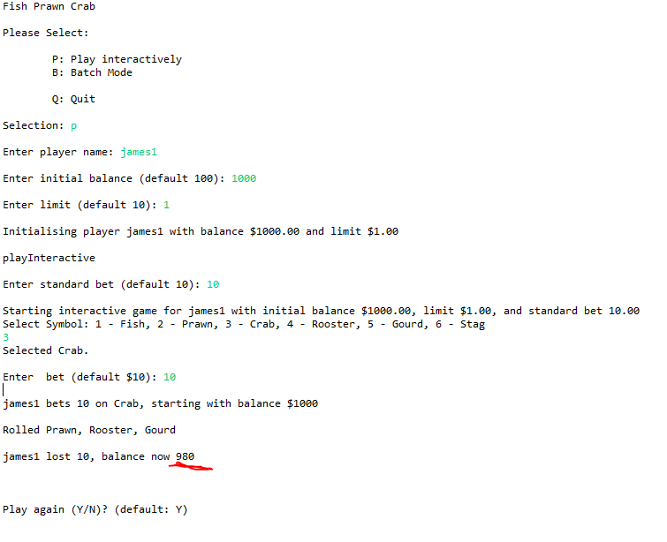Note: All failed attempts in test executions where when the program bet was won not allowing the bug to be seen. All passes where when the program bet was lost, and the bug was seen.

System Cycle 3